**The meeting records**

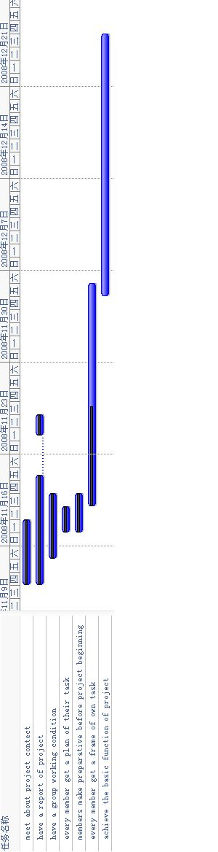



**The first meeting of our group:**

Date: 2008.11.4

Time: 8pm P lace: Room 604 Members: all attendance

Meeting content:

1. “David’s wardrobe” is our IT project. For this project, we get ready for half a month. We know its a little rush, so we do not think about risk and feasibility.

2. Today, we link up with the teacher, he tell us our work load and function are too less. So we just more time to do fewer things. We should develop useful things.

3. Because of this meeting, we divide our work.

Initial plan:

Harry is responsible for web designing, typesetting and toning.

David is responsible for adding some functions.

Annie is responsible for linking up with customer, writing report and shoot pictures.

Amy is responsible for finding information, and shooting pictures.

Betty is responsible for user’s log on and register.

4. In accordance with everyone’s division of labor, we are going on the next step, add functions and workload, also we adjust our efficiency.

5. Before the next meeting start, everyone should hand in their changes plan for their parts.

**The second meeting of our group:**

Date: 2008.11.3

Time: 8pm P lace: Room 604 Members: all attendance

Meeting content:

1. After our project revised, we discuss with teacher again. But teacher still a doubt our project. He think our project no creative and highlights. We can not break through any others same web.

2. Our group discuss again, we decide to give up this project and select another one.

3. We search for information on the web, put forward everyone’s viewpoint. At last, we define our project is original in choice of subject. The highlight is that we can achieve individual design and link up with designer online.

4. We think this project is original in choice of subject. The highlight is that we can achieve individual design and link up with designer online.

5. Initial plan:

Harry is responsible for web designing.

David is responsible for finding customer.

Annie is responsible for contacting with designer, writing report.

Amy is responsible for finding information, arranging fashion news and family fix popular tendency.

Betty is responsible for register, log on and linking up with designer online.

6. Everyone arrange their part, and hand in report next time.

7. Studying some skills and languages which they ate responsible for.

**The third meeting of our group:**

Date: 2008.11.7

Time: 8pm P lace: Room 604 Members: all attendance

Meeting content:

1. We tell teacher we change our project again. When we hand in our report, our teacher feels satisfied. But we still have problems.

2. We all feel a little sad, and think about if it feasible or not. And because of mistake, it lead to different module appears different customers. For working in concert with our project, we decide to find customer from plate part. But our customer should find from big fit up market. It’s difficult for us.

3. Because of no customer, we should find another way to discover a new customer. However, if we direct our direction, we’ll lose the highlight. We don’t know how to break through this project.

4. We all lose confident to do this project well, and can’t find real customer. So we have to give up again, select a new direction.

5. Because of these two failures, we know we should find real customer first, then we can define our project. At last, our project is defined to “Hotel management system”. Our customer is a president works in a hotel. So after we link up with her, we know she hope we can make a system which can achieve both Windows and Web. It’s a more difficult challenge for us, but we can be accepted.

6. Everyone find information, and list detailed function.

Initial plan:

Harry is responsible for two modules function 8 modules. (Detailed operate)

Amy is responsible for two modules function 8 modules. (Detailed operate)

Betty is responsible for two modules function 8 modules. (Detailed operate)

Annie is responsible for two modules function 8 modules. (Detailed operate) and link up with customer, arrange report.

David is responsible for all web part, web skill.

**The fourth meeting of our group:**

Date: 2008.11.14

Time: 11:20am P lace: Room 603 Members: all attendance

Meeting content:

1. Handing in our new project, and a short part of our report. Explaining the function we should achieve and the reason why we change our project again. The teacher helps us to analyze our project, define languages C/S: net beans, Java JDBC SQL-server. Network part: Dreamweaver, PHP, Tomcat. He tells us we need to divide the work, 3 people are responsible for skills, and 2 people are responsible for needs.

2. During teacher asks questions to us, web part is our loophole in this project. So now we think web part need us to study.

3. Our next aim is quicken other group’s step, set up frame.

4. Everyone should study by dividing the work, finishing their work.

5. Keeping on linking up with customer. For achieving a result that customer feels satisfied.

6. Arranging and handing in new report. Think about risk problem.

7. We should work like a team; raise us confident, progress together.

**The fifth meeting of our group:**

Date: 2008.11.17

Time: 16:45pm P lace: Room 102 Members: all attendance

Meeting content:

1. We should hand in the second report this Friday.

2. Next week, we should have a presentation is directed at we finish part.

3. Checking up diary record of work.

4. The next step of plan and the function that everyone wants to achieve.

5. Conclusion everyone’s work during last month, and tell ideas to our team.

6. Link up with team members is important to every team. So we need cost more time to chat with each member to know each one’s thought. It can culture our team tacit understanding.

7. Discussing our next step for the project. Achieving the aim.

8. Studying begin from this minute.